Which bugt I use:

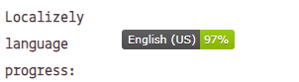

NOT FOUND

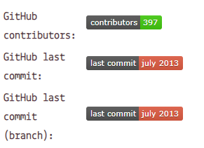

Last commit

![GitHub last commit](<https://img.shields.io/github/last-commit/mahmudgithub/Django-React-CRUD-Operation?logo=github&style=plastic>)

Contributor

![GitHub contributors](<https://img.shields.io/github/contributors/mahmudgithub/Django-React-CRUD-Operation?logo=github&style=plastic>)

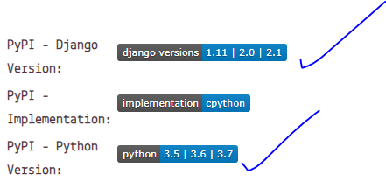

Python version

![PyPI - Python Version](<https://img.shields.io/pypi/pyversions/django?logo=github>)

Django version

![PyPI - Django Version](https://img.shields.io/pypi/djversions/djangorestframework?logo=github&style=for-the-badge)

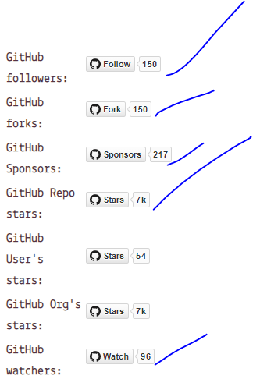

Flower(common)

![GitHub followers](<https://img.shields.io/github/followers/mahmudgithub?logo=github&style=social>)

![GitHub followers](<https://img.shields.io/github/followers/mahmudgithub?style=plastic>)

Fork

![GitHub forks](<https://img.shields.io/github/forks/mahmudgithub/Django-React-CRUD-Operation?style=social>)

![GitHub forks](<https://img.shields.io/github/forks/mahmudgithub/Django-React-CRUD-Operation?logo=github&style=plastic>)

sponsor

![GitHub Sponsors](<https://img.shields.io/github/sponsors/mahmudgithub?logo=github&style=social>)

![GitHub Sponsors](<https://img.shields.io/github/sponsors/mahmudgithub?logo=github&style=plastic>)

Star

![GitHub Repo stars](<https://img.shields.io/github/stars/mahmudgithub/Django-React-CRUD-Operation?logo=github&style=social>)

![GitHub Repo stars](<https://img.shields.io/github/stars/mahmudgithub/Django-React-CRUD-Operation?logo=github&style=plastic>)

Twitter(common)

![Twitter URL](<https://img.shields.io/twitter/url?logo=twitter&style=social&url=https%3A%2F%2Ftwitter.com%2FMahmud_Hossain5>)

![Twitter URL](<https://img.shields.io/twitter/url?logo=twitter&style=plastic&url=https%3A%2F%2Ftwitter.com%2FMahmud_Hossain5>)

Twitter flow(common)

![Twitter Follow](<https://img.shields.io/twitter/follow/Mahmud_Hossain5?logo=twitter&style=social>)

![Twitter Follow](<https://img.shields.io/twitter/follow/Mahmud_Hossain5?logo=twitter&style=plastic>)

Github watch

![GitHub watchers](<https://img.shields.io/github/watchers/mahmudgithub/Django-React-CRUD-Operation?logo=github&style=social>)

![GitHub watchers](<https://img.shields.io/github/watchers/mahmudgithub/Django-React-CRUD-Operation?logo=github&style=plastic>)

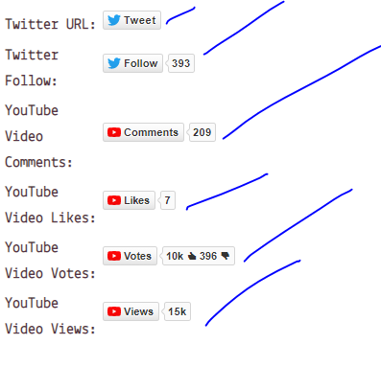

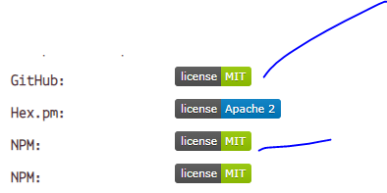

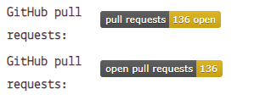

Github lince

[![PyPI license]([https://img.shields.io/pypi/l/ansicolortags.svg)](https://pypi.python.org/pypi/ansicolortags/)](https://img.shields.io/pypi/l/ansicolortags.svg)%5d(https://pypi.python.org/pypi/ansicolortags/))

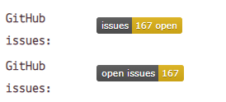

Issues

![GitHub issues](<https://img.shields.io/github/issues/mahmudgithub/Django-React-CRUD-Operation?logo=github&style=social>)

![GitHub issues](<https://img.shields.io/github/issues/mahmudgithub/Django-React-CRUD-Operation?logo=github&style=plastic>)

Github open issue

![GitHub issues](<https://img.shields.io/github/issues-raw/mahmudgithub/Django-React-CRUD-Operation?logo=github&style=plastic>)

Github pull request

![GitHub pull requests](<https://img.shields.io/github/issues-pr/mahmudgithub/Django-React-CRUD-Operation?logo=github&style=social>)

![GitHub pull requests](<https://img.shields.io/github/issues-pr/mahmudgithub/Django-React-CRUD-Operation?logo=github&style=plastic>)

Ask anything

[![Ask Me Anything !]([https://img.shields.io/badge/Ask%20me-anything-1abc9c.svg)](https://GitHub.com/mahmudgithub/Django-React-CRUD-Operation)](https://img.shields.io/badge/Ask%20me-anything-1abc9c.svg)%5d(https://GitHub.com/mahmudgithub/Django-React-CRUD-Operation))

Python related

[![forthebadge made-with-python]([http://ForTheBadge.com/images/badges/made-with-python.svg)](https://www.python.org/)](http://ForTheBadge.com/images/badges/made-with-python.svg)%5d(https://www.python.org/))

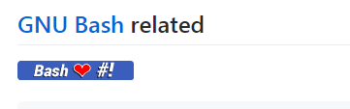

[![Bash Shell](https://badges.frapsoft.com/bash/v1/bash.png?v=103)](https://github.com/ellerbrock/open-source-badges/)



[![Github all releases](https://img.shields.io/github/downloads/Naereen/StrapDown.js/total.svg)](https://GitHub.com/mahmudgithub/StrapDown.js/releases/)



![Profile views](https://gpvc.arturio.dev/mahmudgithub)



[![Only 32 Kb](https://badge-size.herokuapp.com/Naereen/StrapDown.js/master/strapdown.min.js)](https://github.com/Naereen/StrapDown.js/blob/master/strapdown.min.js)

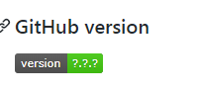

[![GitHub version](https://badge.fury.io/gh/Naereen%2FStrapDown.js.svg)](https://github.com/Naereen/StrapDown.js)

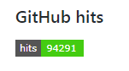

[![HitCount](http://hits.dwyl.io/Naereen/badges.svg)](http://hits.dwyl.io/Naereen/badges)

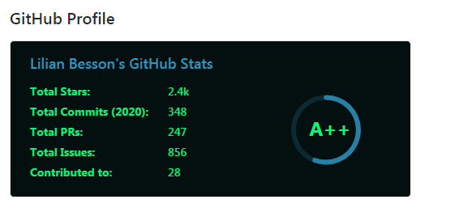

[![Anurag's github stats](https://github-readme-stats.vercel.app/api?username=Naereen&theme=blue-green)](https://github.com/anuraghazra/github-readme-stats)

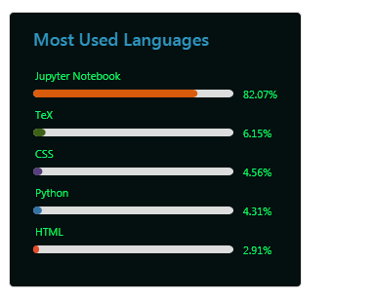

![1](https://github-readme-stats.vercel.app/api/top-langs/?username=Naereen&theme=blue-green)

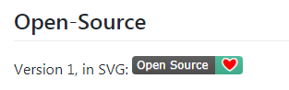

[![Open Source Love svg1](https://badges.frapsoft.com/os/v1/open-source.svg?v=103)](https://github.com/ellerbrock/open-source-badges/)



[![Open Source Love svg3](https://badges.frapsoft.com/os/v3/open-source.svg?v=103)](https://github.com/ellerbrock/open-source-badges/)



[![Open Source? Yes!](https://badgen.net/badge/Open%20Source%20%3F/Yes%21/blue?icon=github)](https://github.com/Naereen/badges/)

[![ForTheBadge built-by-developers](http://ForTheBadge.com/images/badges/built-by-developers.svg)](https://GitHub.com/Naereen/)



[![ForTheBadge uses-html](http://ForTheBadge.com/images/badges/uses-html.svg)](http://ForTheBadge.com)



[![ForTheBadge uses-css](http://ForTheBadge.com/images/badges/uses-css.svg)](http://ForTheBadge.com)

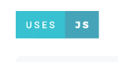

[![ForTheBadge uses-js](http://ForTheBadge.com/images/badges/uses-js.svg)](http://ForTheBadge.com)